**Day 6 - 29/5/2025**

**Barghavi Bethu   
112728766 – bethubal**

**Task 1**

RegEX Symbols in linux. List them down with description

1. . : Matches any single character except new line
2. ^ : Matches the beginning of a line
3. $ : Matches the end of a line
4. * : Matches 0 or more of the preceding characters
5. [] : Matches any one character inside the brackets
6. \ : Escapes a special character
7. ? : Matches 0 or 1 of the preceding element

**Task 2**

What are the imp features of Linux os ?

1. Open source: Source code is freely available under license like GPL. Anyone can view modify and distribute it.
2. Security & permissions: Uses multiuser permissions and security policies. Supports features like file permission (read, write, execute), SELinux, AppArmor(advanced access controls)
3. Multitasking: Can handle with multiple processes simultaneously.
4. Multiuser support: Multi users can log in and work simultaneously without interfering with each other.
5. Stability and reliability: This is well known for uptime and reliability, making it ideal for servers. Systems can run for years without needing a reboot.
6. Hardware compatibility: Supports wide range of hardware. Thousands of drivers are included or available via modules.
7. Portability: Linux can run on many architectures. It is the core od android, routers, loT devices etc.
8. Package management: Uses package managers(apt, yum, dnf, pacman etc.) to install, update and manage software efficiently.

**Task 3**

What is Kernal and can you explain its functions?

Kernel is the core part of an operating system. It acts as a bridge between hardware and software managing how applications and hardware interact. It is the brain of the OS ensuring that everything runs smoothly and securely.

In linux kernel is monolithic but modular, which means it is a large block of code running in memory, bit part of it can be loaded or removed dynamically.

Functions:

1. Process Management:
2. Memory Management
3. Device Management
4. File System Management

**Task 4**

What is BASH? Full form with explanation.

BASH stands for Bourne Again Shell

This is a command line shell and scripting language for automating tasks, commonly used in linux. BASH is an interpreter between the users and the operating system. This allows us to run commands, write scripts to automate tasks, control processes, file operations and more.

**Task 5**

What is the difference between window and linux?

Linux is an open source, Unix-like operating system kernel developed by Linus Torvalds in 1991. Many distributions(like ubuntu, fedora, Debian) are built around the linux kernel and include various tools and user interfaces.

Windows is a commercial, proprietary operating system developed by Microsoft. It is widely used on desktops and laptops for personal and business use.

**Task 6**

Define the basic components of Linux?

Linux os is made up of several key components that work together to manage hardware, run applications and provide user interface.

1. Kernel - Core part of the OS that directly interacts with hardware.
2. System Libraries – Provides functions and tools used by applications to communicate with the kernel.
3. System Utilities – Essential tools and programs for managing the system.
4. Shell – The command line interface for user interaction with the system. Interprets and executes user command
5. File System: Organizes and manages data storage. Linux uses a hierarchical directory structure starting from/root
6. User Space – Area where user application and processes run. Includes desktop environments web browsers, editors etc.

**Task 7**

Is it legal to edit Kernal?

Yes, it is legal to edit the linux kernel – as long as you follow the terms of its license.

**Task 8**

how many of you have gone through techadamy Linux plz raise ur hand. Can you explain LILO?

LILO stands for Linux Loader. It is a boot loader for linux systems – a small program that loads the linux operating system into memory when the computer starts.

When you poweron computer the BIOS/UEFI loads the voot loader which then displays the boot menu(if configurated)

Loads the Linux kernel (or another OS)

Passes control to the kernel to start the OS.

**Task 9**

What is shell? How many shells are there and what are they ? can you explain?

In linux and other unix-like systems, a shell is a command – line interpreter a program that takes user input(commands) and translates it into actions the operating system can perform.

Think of the shell as the bridge between the user and the kernel of the operating system.

Shell accepts and interprets commands typed by the user. It executes commands like listing files, copying anc compiling codes. Allows scripting and automation through shell scripts.

Manages environment variables and I/O redirection.

Types of shells:

Bourne Shell – sh – The original Unix shell; simple and portable.

Bourne Again Shell – bash – The most widely used shell, default on many Linux systems

C Shell – csh – C – like syntax, includes job control features

TENEX C Shell – tcsh – Enhanced version of cs with auto completion.

Korn Shell – ksh – Combines features of sh, csh, and bash used in enterprise unix

Z Shell – zsh – Powerful, customizable shell, popular among developers.

Fish Shell – fish – Friendly, interactive shell:, modern syntax with rich features.

**Task 10**

What is Swap space?

When our system runs out of RAM, Linux moves inactive pages(program data which doesn’t need currently) from RAM to swap space to freeup memory for active processes to prevent system crashes or slowdowns.

1. Swap Partition: A dedicated partition on the disk set aside for swap

2. Swap File: A regular file that acts like swap space(more flexible)

**Task 11**

What is Mount? how do you mount and unmount file system in Linux?

Mount is a system command used to attach a storage or file system to the existing linux file system, the process of attaching a filesystem (like USB drive, hard disk partition or ISO image) to a specific directory in the linux directory tree. This makes the files and directories on that device accessible to the system.

EX while plugging in USB it is not automatically ready for use until it is mounted. Once mounted its contents are accessible to the regular files.

Linux tests everything as a file including hardware devices.

Basic syntax

BASH

sudo mount <device> <mount_point>

Example: sudo mount /dev/sdb1 /mnt/usb

/dev/sdb1 – stiorage device(like usb or partition)

mnt/usb – the directory where it is mounted

Unmount is the reverse of mount operation. Unmount is used to detach a mounted device from the system. This prevents damage or corruption that could occur if a device is removed while the data is being written. We have to make sure that the device is not in use before unmounting.

sudo unmount <mount_point> or device>

Example: sudo unmount /mnt/usb

sudo unmount /dev/sdb1

**Task 12**

What is chmod command? how to use it?

Chmod: change mode

It is used to set or change the permissions of files and directories in Linux. This uses a permission model to control who can read, write or execute a file or directory. Chmod allows you to modify these permissions.

Each file or directory

Each file or directory has three types of access permissions for three categories of users:

User Category Meaning

u User(owner of the file)

g Group(users in the file’s group)

o Others (everyone else)

Permission Symbol Meaning

Read r View contents

Write w Modify contents

Execute x Run as program/script

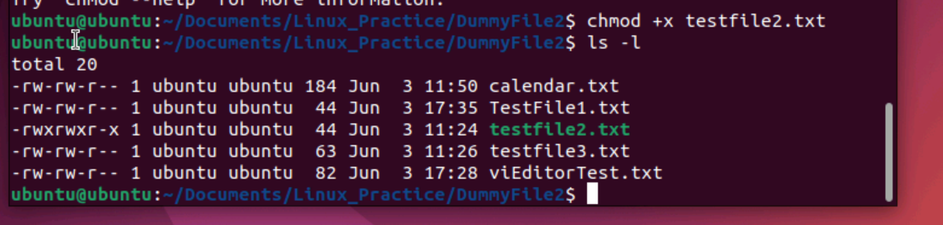

**Task 13**

Can you add a new user account? Crate a new user in different ways and paste ss?

Yes we can add new user account.

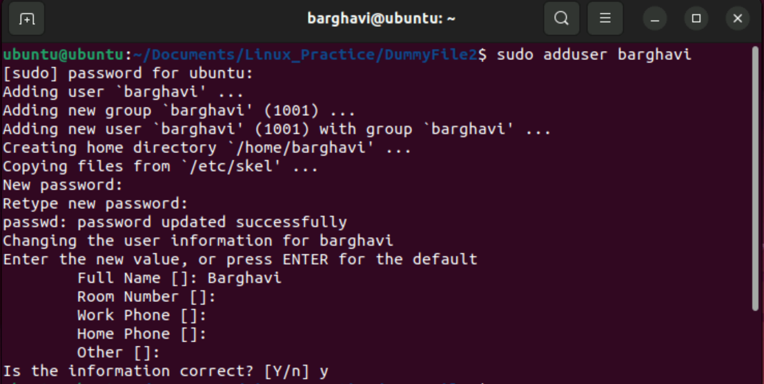

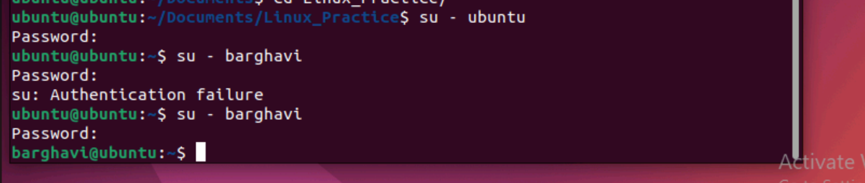

**Task 14**

Can you change the password of a user? How do you do that? Plz share ss?

Yes we can change password

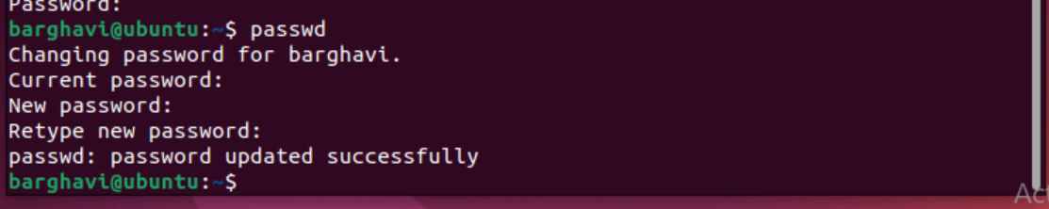

**Task 15**

What is diff between Process and Thread?

Process – An independent program in execution. Has its own memory space, resources and atleast one thread. When you open a program like a web browser or a terminal, the operating system created a new process. This process runs in its own protected memory space, meaning

It cannot directly access the memory of other processes. This isolation provides security and stability.

Thread – A lightweight unit of execution within a process. Shares the same memory and resources as other threads in the same process but operate independently and can run concurrently.

For example, one thread might handle the user interface them another might download a file, another might render images. Since that all belongs to the same process, they can easily share data, which makes communication fast. But if one thread causes an error it can crash the entire process.

**Task 16**

Doc 14 Linux Grep commands .. plz work on it

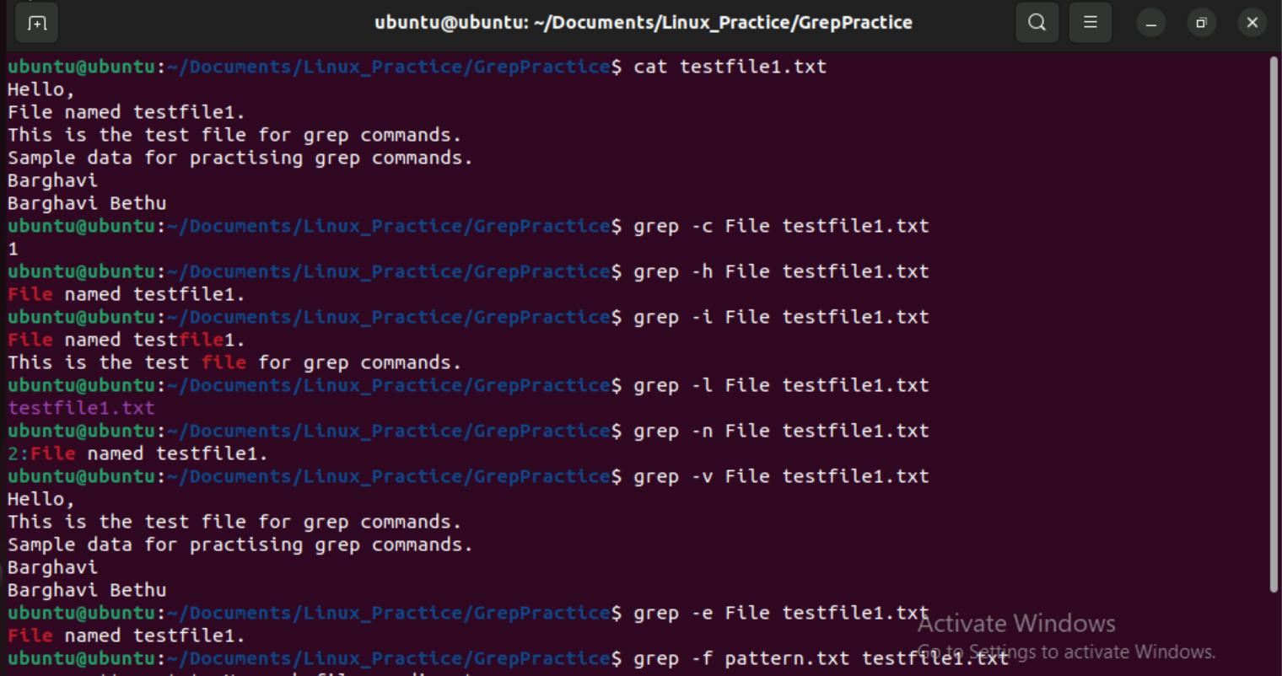

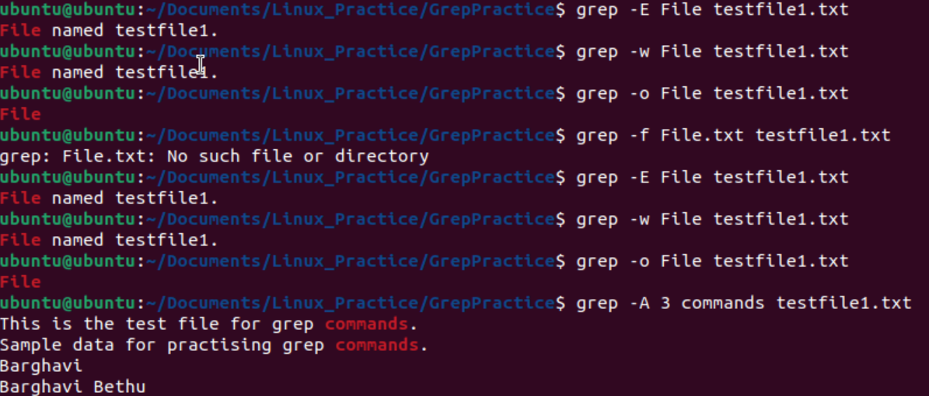

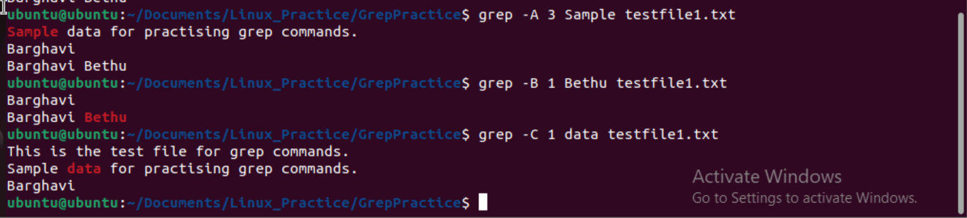

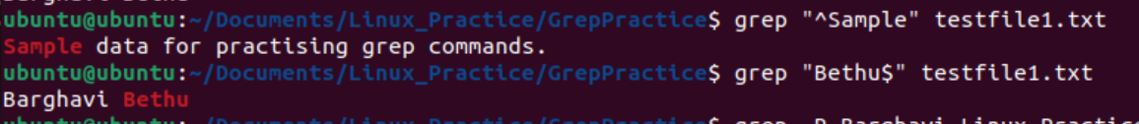

**Task 17**

AWK commands in doc 15 Linux AWK commands

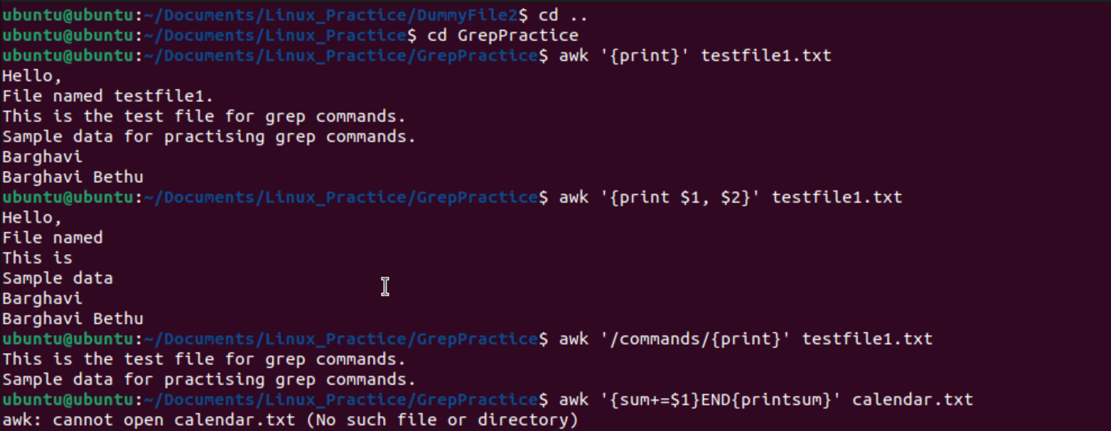

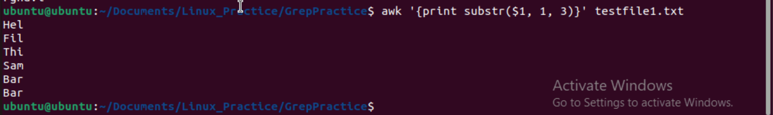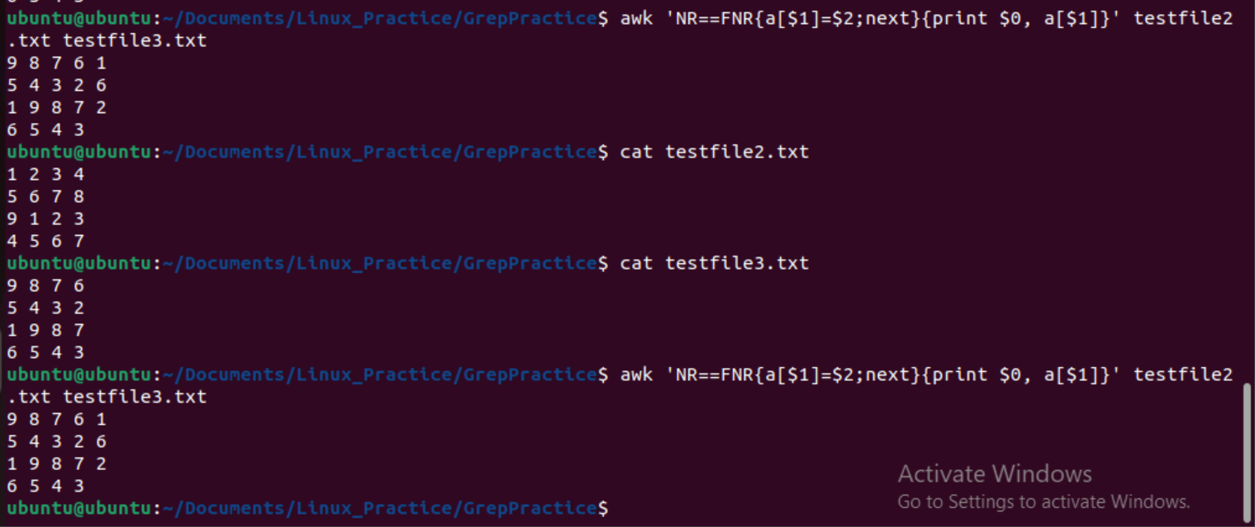

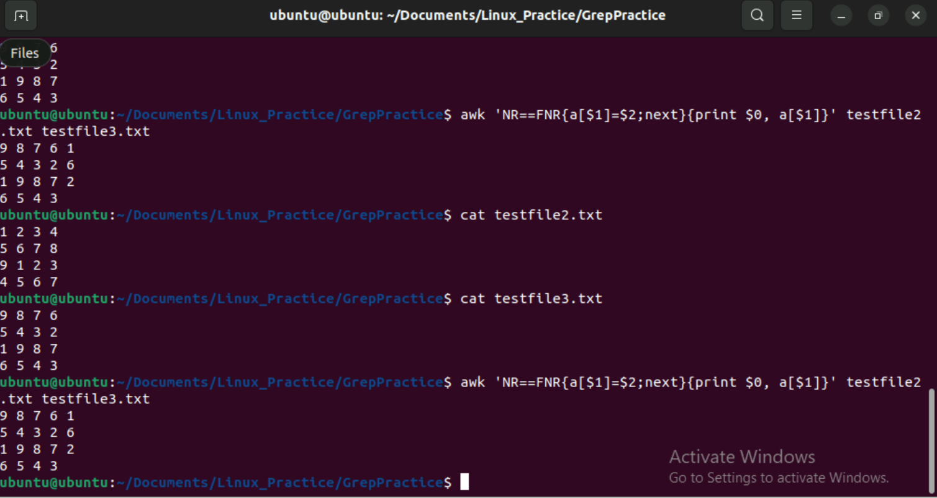

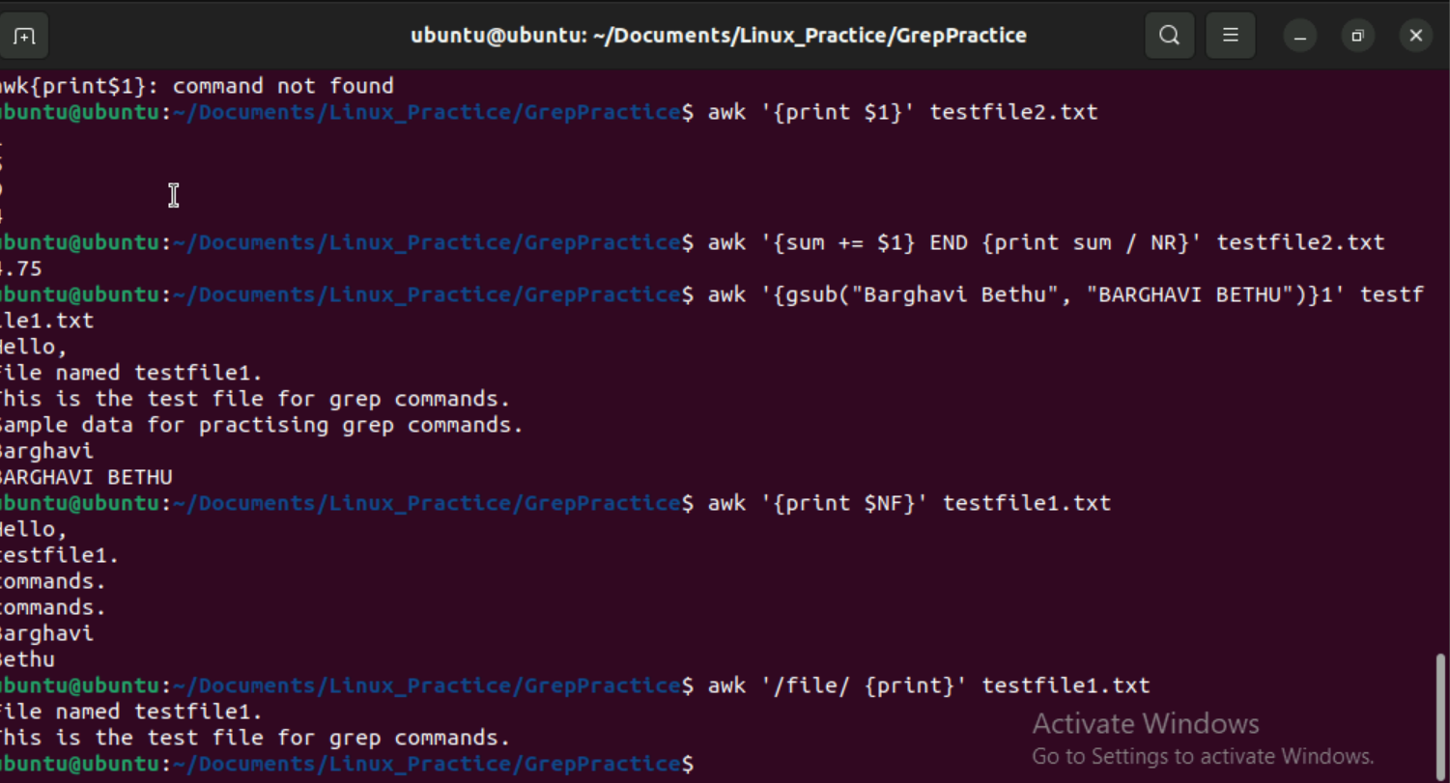

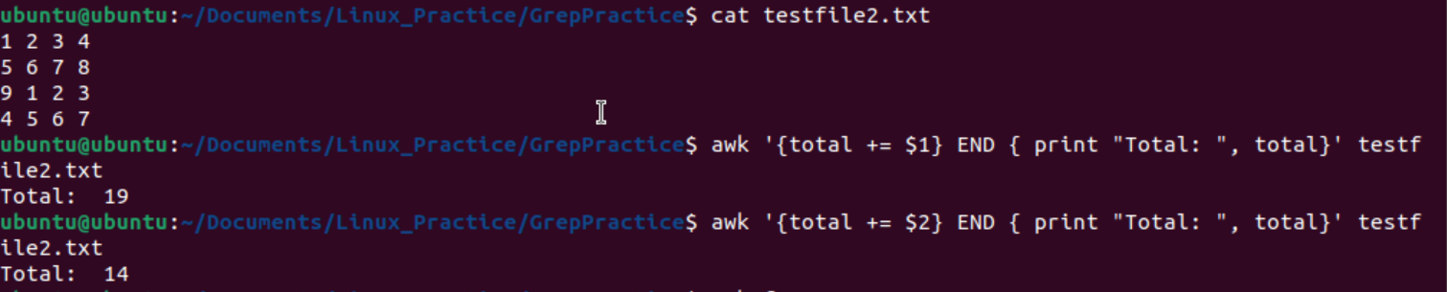

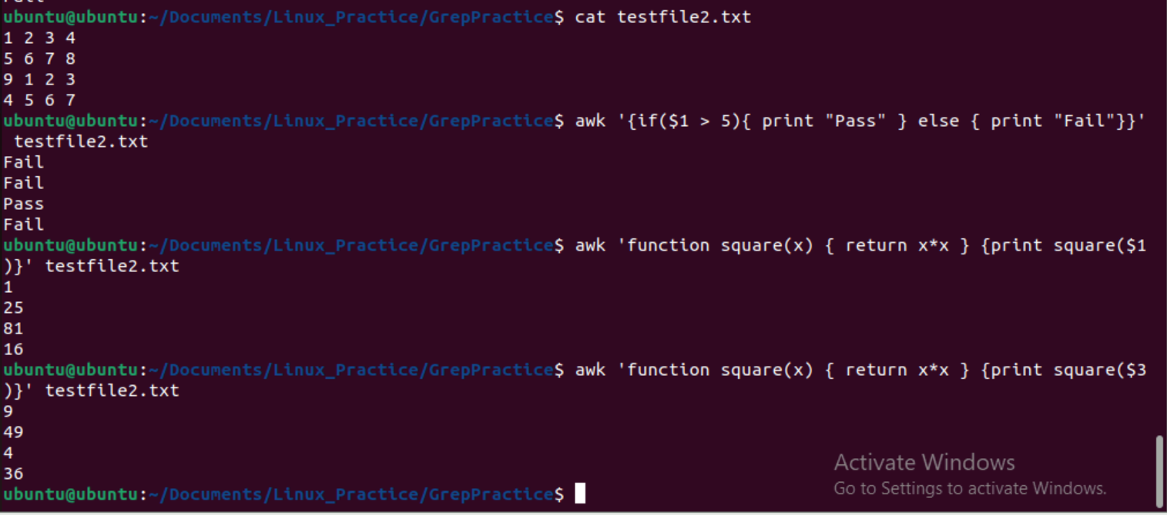

**Task 18:**

How to check file access permission in Linux?

Hint use:

 Ls -l

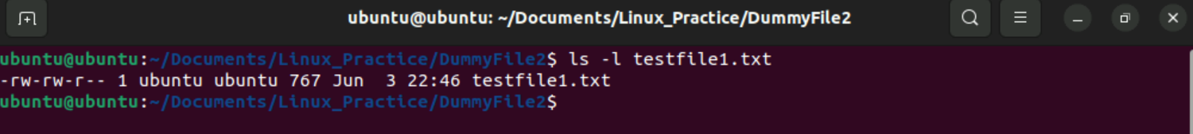

**Task 19:**

What are the default permissions for a new file ?

Plz find out for

Owner   → read, write

Group → read, write

All and others → read

Juz write no ss req

**Task 20:**

What is the command to change the permission to read only for the owner, group and all other users

Hint: chmod 444 filename

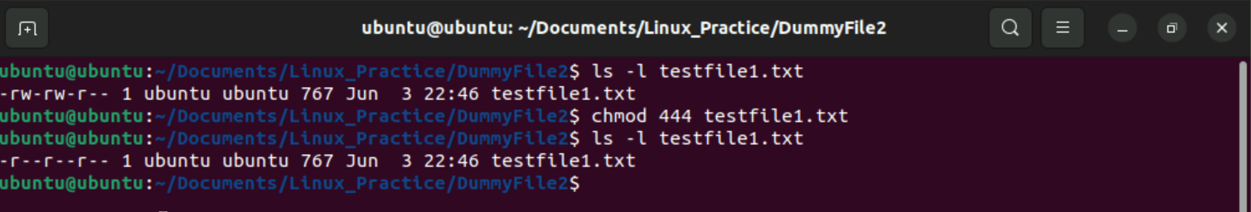

**Task 21:**

Can you change the file permissions to match the following:

* owner: Read and Write
* group: Read
* other: no permissions (None)

Yes we can change the permissions to -rw-r-----

**Task 22:**

What was the command for changing the file permissions to -rw-r-----?

Hint : use chmod 640 filename

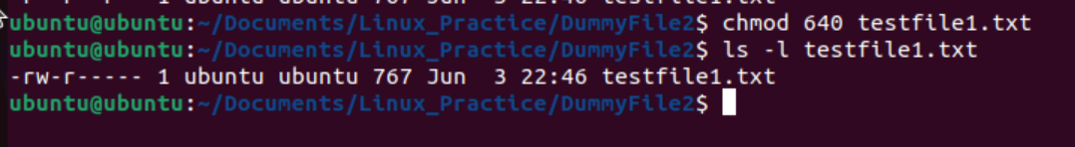

**Task 23:**

Change chmod.exercises permissions to -rwxr-x--x

Change the file permissions to match the following:

owner: Read, Write and Execute

group: Read and Execute

other: Execute

**Task 24:**

What was the command for changing the file permissions to -rwxr-x--x

Hint : use chmod 751 filename

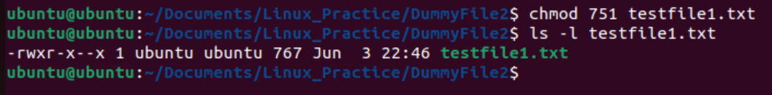

**Task 25:**

Guys what will this command do?

chown -c master file1.txt

chown command is used to change ownership of file or directory.

**Task 26:**

Can you define what is  a process?

A process in Linux is an instance of running program. Wherever you run a command or open an application system created a process to execute it.

This has a unique process ID(PID), it runs in its own memory space. It may create child processes, it is managed by kernel.

**Task 27:**

What is command to check foreground process and background process

Command to check foreground process – nano – This runs directly in terminal

Command to run background process – gedit & - Runs in background using &

**Task 28:**

Can you list all the running processes?

Hint use ps

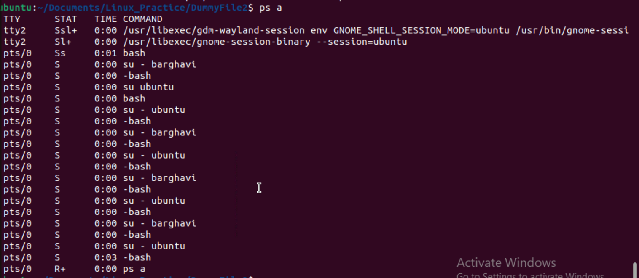

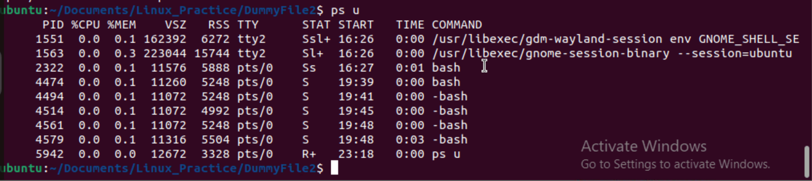

**Task 29:**

What will ps -f command do ? plz try n check .. ss required.

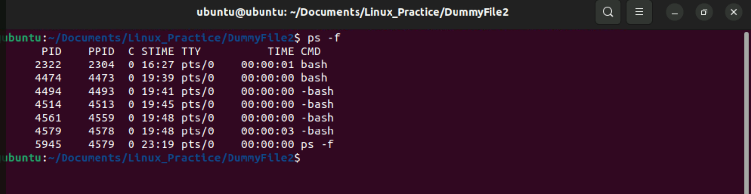

**Task 30:**

Can you createa  a variable name with your name in it

Ex:

Name =  “prasunamba”

Id  = 10001

And check

Echo $Name

Chek the output

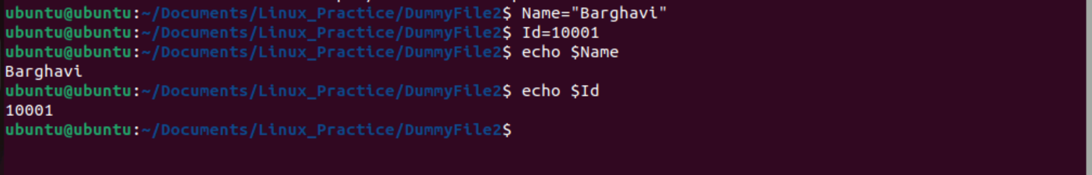

**Task 31:**

Can you make the above name variable read only..

Ex:

Name = “Prasunamba”

Readonly Name

Name = “Meher” —>what will this display.. Is it saying read only?? Pl check

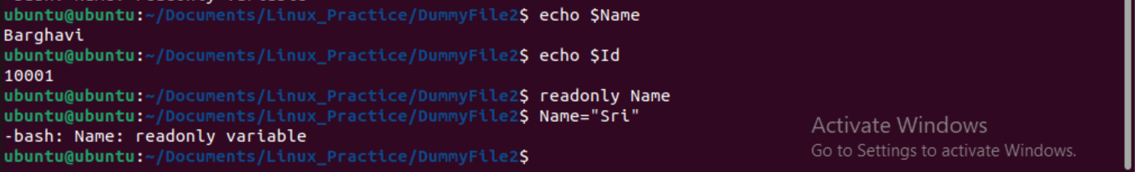

**Task 32:**

Now will unset or delete the variables

Use the below command and check

Unset Name

Now check for

 echo $Name   —> this should not print anything.. Plz try also specify the reason



Name is changed as readonly, hence not able to unset